Peril on Lake Erie

By Barry D. Wood

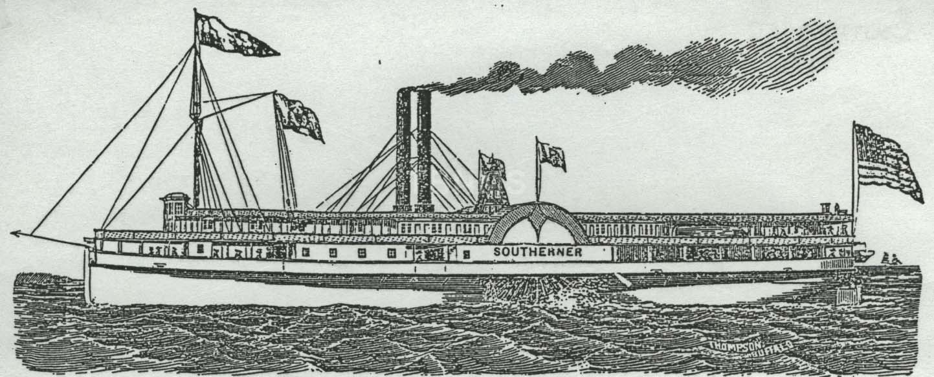

On Friday evening April 5, 1851 the paddle-wheeler Southerner departed Cleveland on its regular run to Detroit 168-miles to the northwest. Only four years old the Southerner and its sister ship Baltimore were the pride of the new Detroit and Cleveland Steam Ship Company. Like on so many earlier sailings Southerner’s decks were crammed with settlers and their luggage. The immigrants had purchased land in Michigan, Wisconsin or Minnesota where they were starting new lives. Most began their American journey in New York, proceeded up the Hudson River to Albany, and then west along the Erie Canal to Buffalo and finally Cleveland.

Ice flows from the winter thaw and strong westerly winds hampered Southerner’s forward movement. Hugging Lake Erie’s southern shore progress came to a halt at Avon Point near Lakewood only 28 miles from Cleveland. There the wind had turned to a gale. The ship was blown onto a rock, its twin smoke stacks were jolted loose and crashed onto the deck. Miraculously no one was killed or injured.

Eighteen-year-old Solomon Miller, my great-great grandfather, was a passenger aboard Southerner. He told his grand-nephew, Russel Hilbert, that all able-bodied men sprang into action, manning the pumps and stuffing mattresses and blankets into the gaping hole. Amazingly, Southerner’s engine continued to function until four o’clock Saturday morning. Finally, a rescue ship appeared, the side-wheeler Arrow. Ropes were attached and the stricken, heavily listing Southerner was towed into Trenton just south of the Detroit River.

The only losses were settlers’ trunks, cargo and deck furniture, all of which was swept overboard into the raging waters.

The April 8, 1851 Detroit Free Press reported on the near disaster.

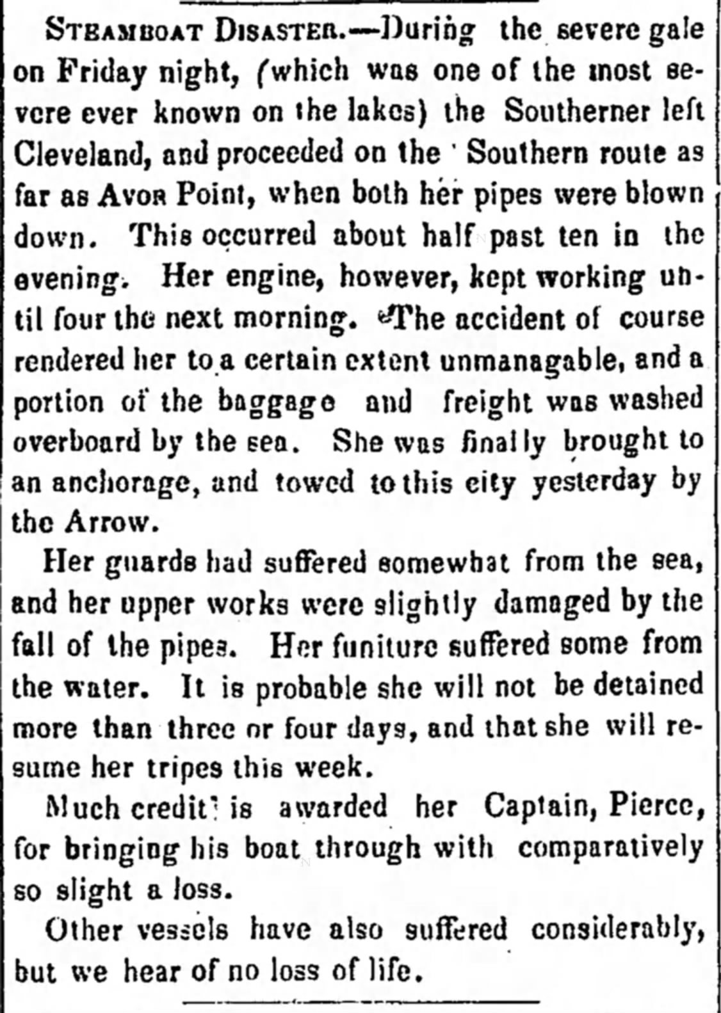

The story of Southerner also appeared in Elyria (Ohio) Courier.

The Southerner was repaired and back in service ten-days later. Its 35-year-old Captain, L.A. Pierce, was commended for his courage and skill in saving the ship. A Vermonter who had come west with the arrival of steam navigation on the Great Lakes, Pierce became a Democratic Party leader in Cleveland. In 1855 he was promoted to general agent for the Cleveland and Detroit line, an affiliate of the Michigan Central railroad. He died in 1881.

The Southerner continued to carry passengers between Buffalo, Cleveland, Detroit and Chicago for two and a half more years. In October 1853 it broke apart and sank during a storm near Ashtabula, Ohio.

In the 1850s Detroit was a busy port with as many as ten ships arriving and departing daily during the season. Monroe, a Lake Erie port between Detroit and Toledo, was a ship building center where Southerner was built and launched in 1847.

The immigrants, including Solomon Miller, were relieved to have reached Detroit alive. Most boarded the cars of the Michigan Central railroad to continue their journey west.

Solomon Miller, a big man who had grown up near Kent, Ohio, was in a hurry to reach Allegan County south of Grand Rapids where his three brothers and two sisters had already settled. Reaching Kalamazoo on the Michigan Central, Miller was unwilling to wait for the three-times a week stagecoach. Instead he chose to walk the 28-miles to Wayland in Allegan County. Beginning a career as a farmer and lumberjack, he married Mary Sephronia Hess, a young woman whose family had migrated from central New York. Together they raised a large family. They died within three years of each other during the first world war. #

(The writer wishes to thank Eric Dalton of the Detroit Historical Society and Don La Barre of the Alpena County Public Library for their valuable assistance.)

